发送数据

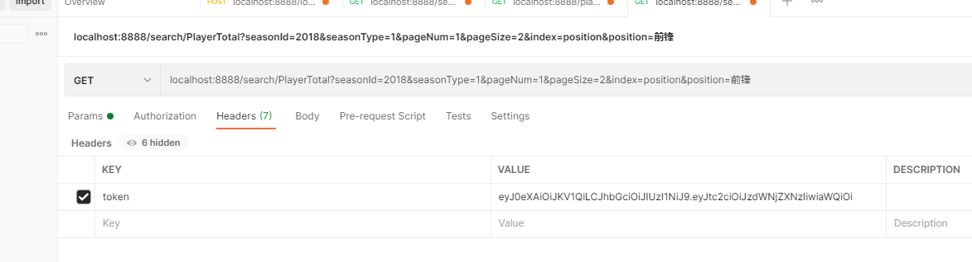

token统一放在headers中

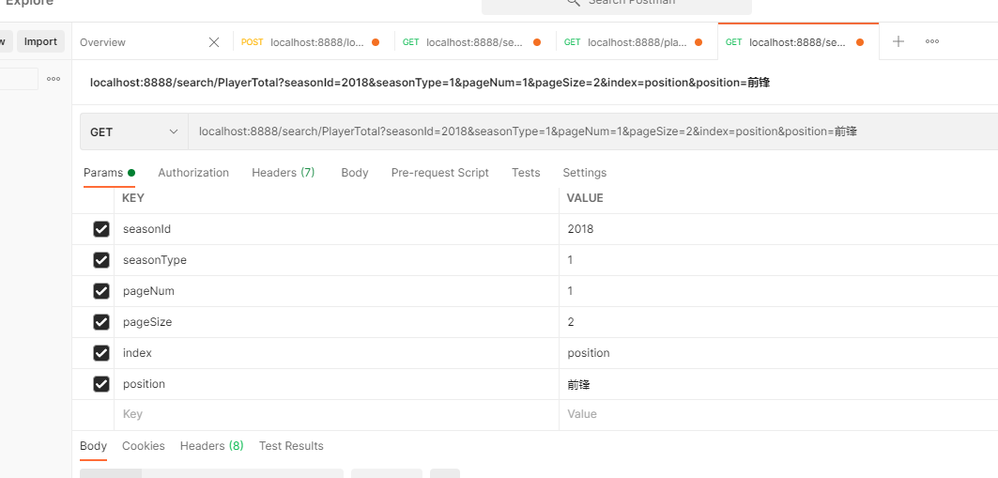

get方式的参数

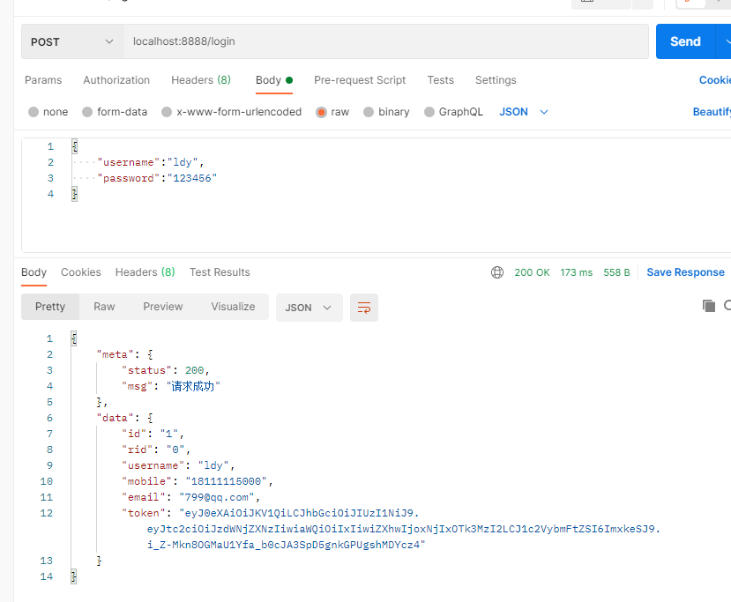

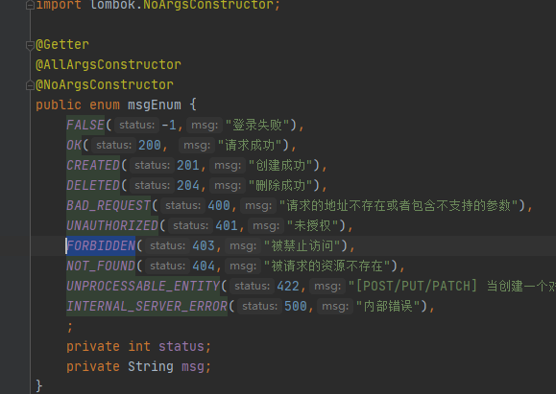

定义的错误码很多但用的不多

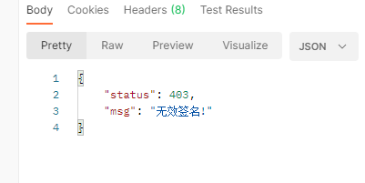←token有问题

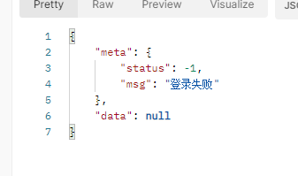账号密码有误

登录post的参数

localhost:8888/login

@RequestBody Map<String,Object> LoginForm) throws Exception {  
 String username= (String) LoginForm.get("username");  
 String password= (String) LoginForm.get("password");

一个表单里放了一个username放了一个password

注册也是post的参数

localhost:8888/login/register

Username password rid mobile email 自行设定好了再发后端，一般给rid默认0是普通用户，1管理员

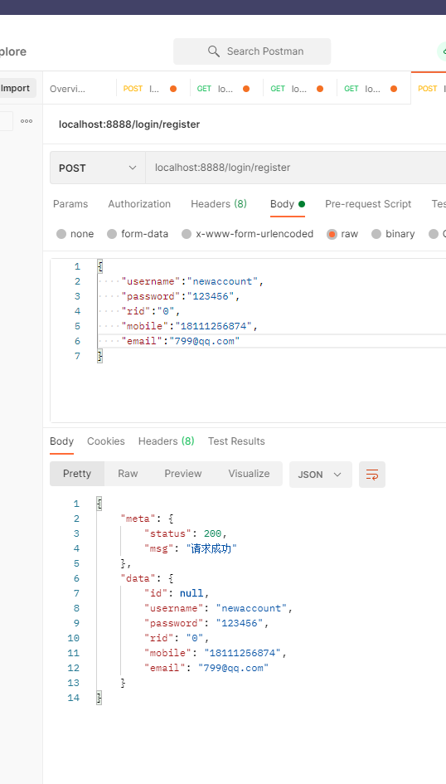

localhost:8888/search/team

@RequestParam(required = false,value = "seasonId") String seasonId,  
@RequestParam(required = false,value = "seasonType") String seasonType,  
@RequestParam(required = false,value = "pageNum") String pageNum,（在前端切换查询信息后最好重新从第一页开始看，当当前pagenum大于总共page的情况的处理方式没写）  
@RequestParam(required = false,value = "name") String name,  
@RequestParam(required = false,value = "pageSize") String pageSize,  
@RequestParam(required = false,value = "index") String index 按照哪一列来排序

{

    "meta": {

        "status": 200,

        "msg": "请求成功"

    },

    "data": {

        "pageData": [

            {

                "seasonId": "2018",

                "seasonType": "1",

                "teamId": "15",

                "fullCnName": "密尔沃基雄鹿",

                "city": "威斯康星州密尔沃基",

                "conference": "east",

                "logo": "http://mat1.gtimg.com/sports/nba/logo/1602/15.png",

                "coach": "迈克-布登霍尔泽",

                "venue": "费哲球馆",

                "points": "9686.0",

                "pointsPG": "118.1",

                "fgAttempted": "7471.0",

                "fgAttemptedPG": "91.11",

                "fgPCT": "0.476",

                "threesAttempted": "3134.0",

                "threesAttemptedPG": "38.22",

                "threesMade": "1105.0",

                "ftAttempted": "1904.0",

                "ftAttemptedPG": "23.22",

                "ftPCT": "0.773",

                "rebounds": "4078.0",

                "reboundsPG": "49.7",

                "offensiveRebounds": "762.0",

                "offensiveReboundsPG": "9.3",

                "defensiveRebounds": "3316.0",

                "defensiveReboundsPG": "40.4",

                "assists": "2136.0",

                "assistsPG": "26.0",

                "steals": "615.0",

                "stealsPG": "7.5",

                "blocks": "486.0",

                "blocksPG": "5.93",

                "cnName": "雄鹿"

            },

            {

                "seasonId": "2018",

                "seasonType": "1",

                "teamId": "9",

                "fullCnName": "金州勇士",

                "city": "美国加州奥克兰",

                "conference": "west",

                "logo": "http://mat1.gtimg.com/sports/nba/logo/black/9.png",

                "coach": "史蒂夫-科尔",

                "venue": "大通中心",

                "points": "9650.0",

                "pointsPG": "117.7",

                "fgAttempted": "7361.0",

                "fgAttemptedPG": "89.768",

                "fgPCT": "0.491",

                "threesAttempted": "2824.0",

                "threesAttemptedPG": "34.439",

                "threesMade": "1087.0",

                "ftAttempted": "1672.0",

                "ftAttemptedPG": "20.39",

                "ftPCT": "0.801",

                "rebounds": "3787.0",

                "reboundsPG": "46.2",

                "offensiveRebounds": "797.0",

                "offensiveReboundsPG": "9.7",

                "defensiveRebounds": "2990.0",

                "defensiveReboundsPG": "36.5",

                "assists": "2413.0",

                "assistsPG": "29.4",

                "steals": "625.0",

                "stealsPG": "7.62",

                "blocks": "525.0",

                "blocksPG": "6.4",

                "cnName": "勇士"

            }

        ],

        "pageNum": "1",

        "totalPage": "15"

    }

}

localhost:8888/search/player

@RequestParam(required = false,value = "teamId") String teamId,  
@RequestParam(required = false,value = "teamName") String teamName,  
 @RequestParam(required = false,value = "name") String name人名//如老鹰的的有60个人，但不知道要取哪些部分

{

    "meta": {

        "status": 200,

        "msg": "请求成功"

    },

    "data": [

        {

            "playerId": "1962937410",

            "enName": "Kris Dunn",

            "cnAlias": "邓恩",

            "birthDate": "1994-03-18",

            "teamId": "1",

            "teamName": "老鹰",

            "jerseyNum": "32",

            "position": "后卫",

            "height": "190CM",

            "weight": "93.0KG",

            "honor": "1",

            "draftYear": "2016",

            "picFromSIB": "https://nba.sports.qq.com/media/img/players/head/260x190/1627739.png",

            "cnName": "克里斯-邓恩"

        },

        {

            "playerId": "1962937499",

            "enName": "Quincy Ford",

            "cnAlias": "福特",

            "birthDate": "1993-01-20",

            "teamId": "1",

            "teamName": "老鹰",

            "jerseyNum": "16",

            "position": "前锋-后卫",

            "height": "203CM",

            "weight": "102.0KG",

            "honor": "1",

            "draftYear": "2016",

            "picFromSIB": "http://mat1.gtimg.com/sports/nba/logo/qymoren.png",

            "cnName": "昆西-福特"

        },

        {

            "playerId": "1962937561",

            "enName": "Winston Shepard",

            "cnAlias": "谢泊德",

            "birthDate": "1993-09-22",

            "teamId": "1",

            "teamName": "老鹰",

            "jerseyNum": "14",

            "position": "前锋",

            "height": "203CM",

            "weight": "98.4KG",

            "honor": "1",

            "draftYear": "0",

            "picFromSIB": "http://mat1.gtimg.com/sports/nba/logo/qymoren.png",

            "cnName": "温斯顿-谢泊德"

        }

    ]

}

localhost:8888/search/PlayerTotal

@RequestParam(required = false,value = "seasonId") String seasonId,年  
@RequestParam(required = false,value = "seasonType") String seasonType,哪个赛季-》季前赛常规赛和季后赛

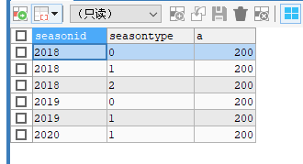  
@RequestParam(required = false,value = "index") String index, 按照哪一列来排序（数据库列名）  
@RequestParam(required = false,value = "position") String position, 位置，前中锋什么的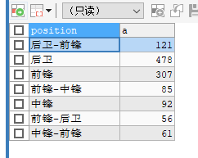  
@RequestParam(required = false,value = "pageNum") String pageNum, 当前是第几页从1开始123456  
@RequestParam(required = false,value = "teamId") String teamId, 队伍编号  
@RequestParam(required = false,value = "name") String name, 成员名  
@RequestParam(required = false,value = "teamName") String teamName, 队伍名  
@RequestParam(required = false,value = "pageSize") String pageSize 每页数据多少

发回来的数据

{

    "meta": {

        "status": 200,

        "msg": "请求成功"

    },

    "data": {

        "pageData": [

            {

                "seasonId": "2018",

                "seasonType": "1",

                "playerId": "1962937408",

                "enName": "Ben Simmons",

                "teamId": "20",

                "teamName": "76人",

                "points": "1337.0",

                "pointsPG": "16.9",

                "fgAttempted": "960.0",

                "fgAttemptedPG": "12.152",

                "fgPCT": "0.563",

                "threesAttempted": "6.0",

                "threesAttemptedPG": "0.076",

                "threesMade": "0.0",

                "ftAttempted": "428.0",

                "ftAttemptedPG": "5.418",

                "ftPCT": "0.6",

                "rebounds": "697.0",

                "reboundsPG": "8.8",

                "offensiveRebounds": "172.0",

                "offensiveReboundsPG": "2.2",

                "defensiveRebounds": "525.0",

                "defensiveReboundsPG": "6.6",

                "assists": "610.0",

                "assistsPG": "7.7",

                "steals": "112.0",

                "stealsPG": "1.4",

                "blocks": "61.0",

                "blocksPG": "0.8",

                "turnovers": "274.0",

                "turnoversPG": "3.5",

                "fouls": "209.0",

                "foulsPG": "2.6",

                "games": "79.0",

                "minutes": "2700.0",

                "minutesPG": "34.2",

                "position": "后卫-前锋",

                "cnName": "本-西蒙斯"

            },

            {

                "seasonId": "2018",

                "seasonType": "1",

                "playerId": "4614",

                "enName": "DeMar DeRozan",

                "teamId": "24",

                "teamName": "马刺",

                "points": "1635.0",

                "pointsPG": "21.2",

                "fgAttempted": "1313.0",

                "fgAttemptedPG": "17.052",

                "fgPCT": "0.481",

                "threesAttempted": "45.0",

                "threesAttemptedPG": "0.584",

                "threesMade": "7.0",

                "ftAttempted": "441.0",

                "ftAttemptedPG": "5.727",

                "ftPCT": "0.83",

                "rebounds": "462.0",

                "reboundsPG": "6.0",

                "offensiveRebounds": "54.0",

                "offensiveReboundsPG": "0.7",

                "defensiveRebounds": "408.0",

                "defensiveReboundsPG": "5.3",

                "assists": "475.0",

                "assistsPG": "6.2",

                "steals": "86.0",

                "stealsPG": "1.1",

                "blocks": "36.0",

                "blocksPG": "0.5",

                "turnovers": "199.0",

                "turnoversPG": "2.6",

                "fouls": "177.0",

                "foulsPG": "2.3",

                "games": "77.0",

                "minutes": "2688.0",

                "minutesPG": "34.9",

                "position": "后卫-前锋",

                "cnName": "德玛尔-德罗赞"

            }

        ],

        "pageNum": "1",

        "totalPage": "49"

    }

}

user表：